**Elaboration Deliverable #2 -** Black Queen Card Game

User story:

“As a player with maximum bid points, I want to decide the trump and announce two cards from the entire deck for the current round so that I can decide on my partners.”

Use Case 1: Happy path scenario

Use Case 2: Rainy scenario



Sequence diagram showing the interactions of human play script of Black Queen Card Game.

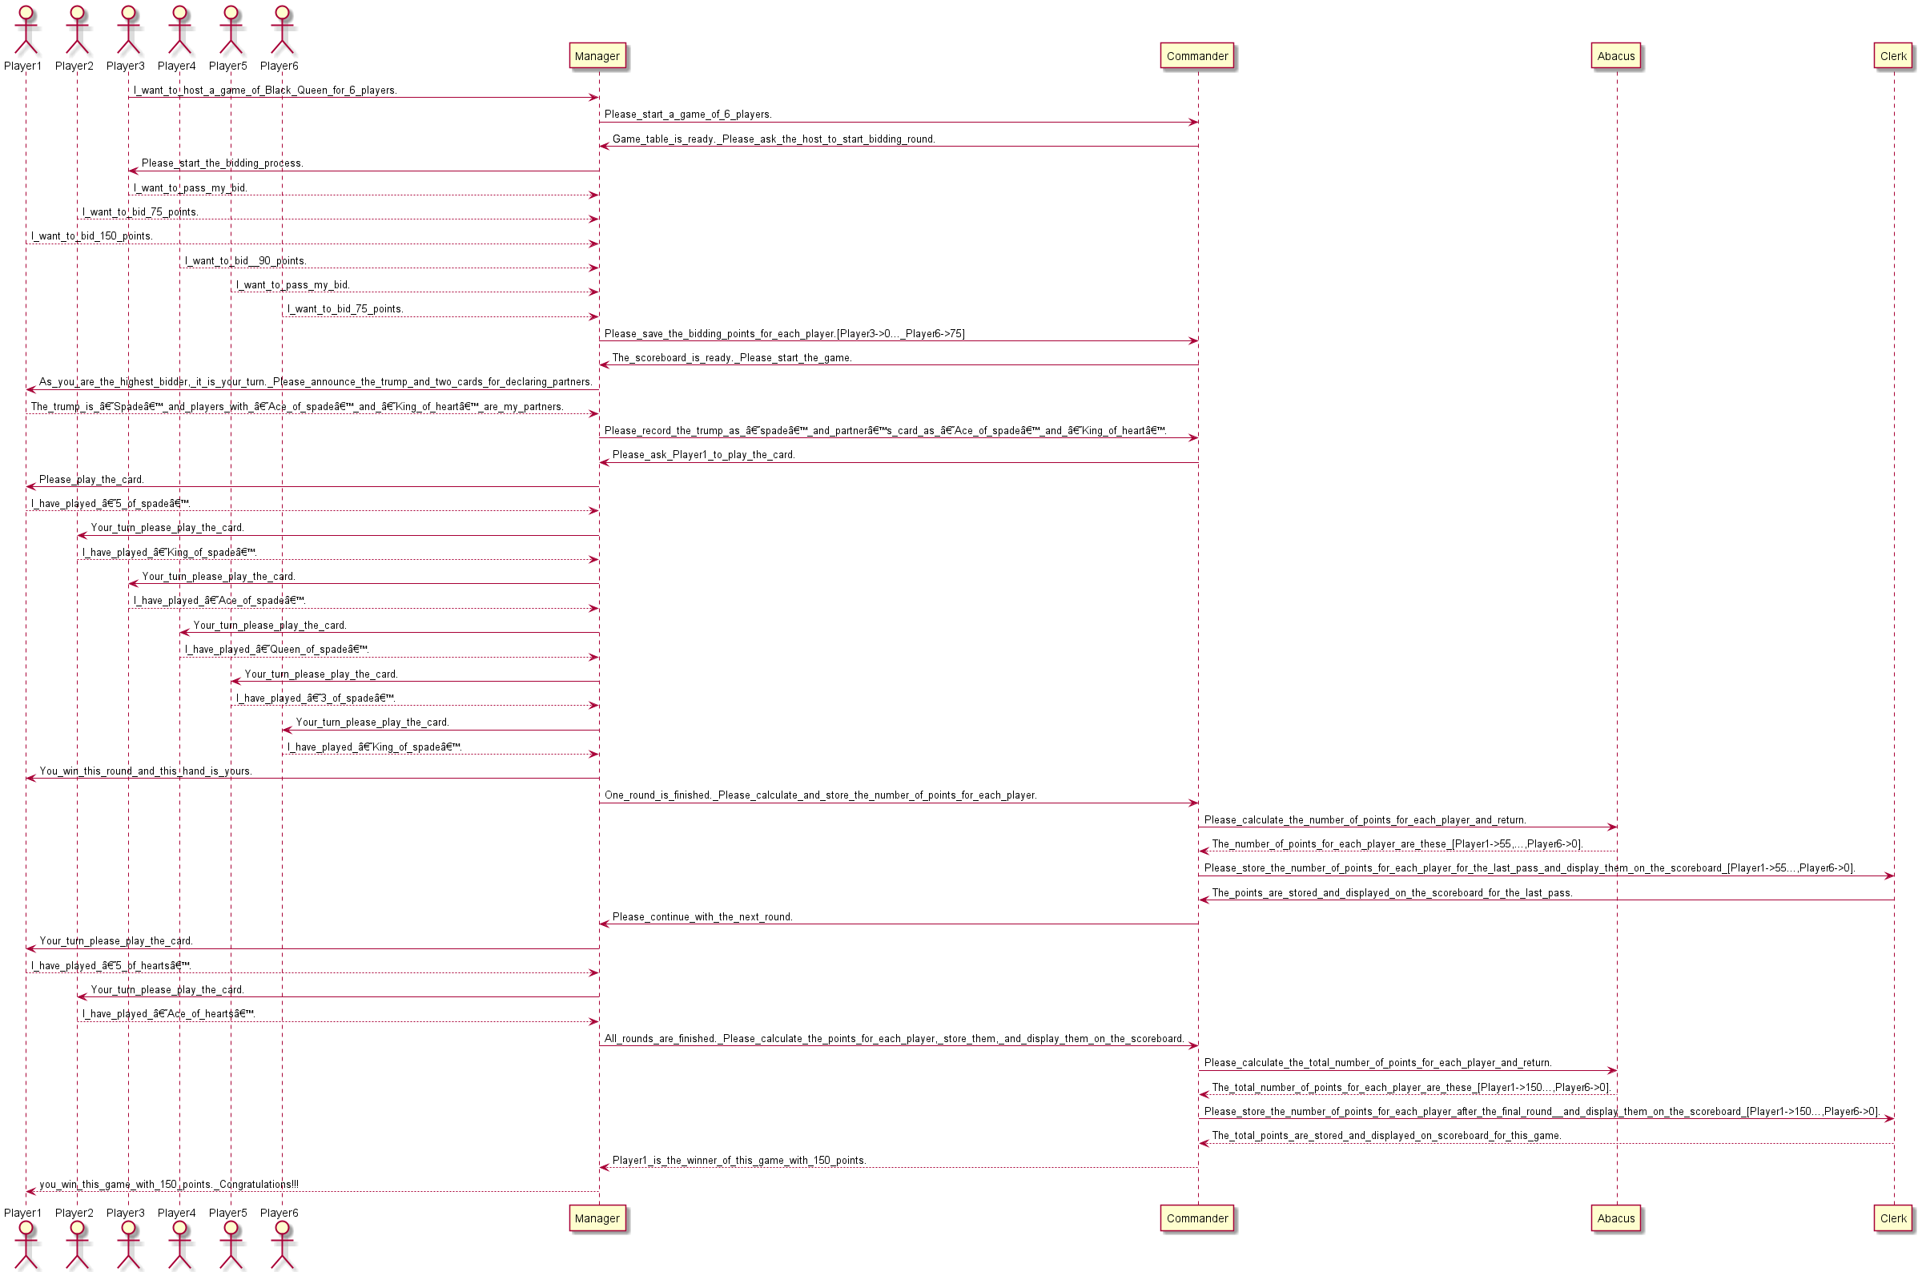

Class diagram from the sequence diagram created above.

